Microplastics in the sediments of the Norwegian Continental Shelf

Arne Pettersen¹, Hans Peter Arp¹, Heidi Knutsen¹, Emma Jane Wade¹

Thomas Møskeland², Jens Laugesen²
¹Norwegian Geotechnical Institute, Environmental Technology, Sognsveien 72, Oslo, Norway  ²DNV-GL, Veritasveien 1, Høvik, Oslo, Norway | Phone: +47 909 25 252  E-mail: arne.pettersen@ngi.no

Introduction: During the regional environmental sediment monitoring on the Norwegian Continental Shelf on behalf of the Oil & Gas industry in 2017, 35 sediment samples from a large geographical area were sampled, covering the central North Sea, northern North Sea and the Barents Sea. The sediment samples were analyzed for microplastics concentrations and number of items by an innovative analytical procedure.

Methods: NGI has developed a novel analytical method for the determination of quality and quantity of microplastic in sediment, water and biota samples. This method was applied on 35 samples collected from a large geographical area were sampled, covering the central North Sea, northern North Sea and the Barents Sea.

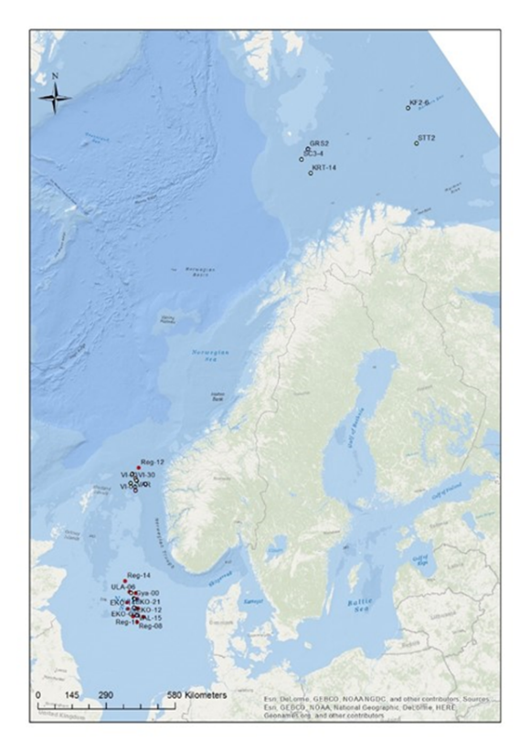
Fig. 1: Map of stations sampled in the study.
Results: A maximum average of 60 ± 80 mg microplastics/kg dry sediment (corresponding to a maximum of 37 000 ± 50 000 items/m2 sediment surface) of potential microplastics were found in the sediment samples from the Norwegian Continental Shelf.
The central North Sea had more microplastics than in the northern North Sea or Barents Sea areas, on maximum average 90 ± 100, 30 ± 40 and 30 ± 20 mg microplastics/kg dry sediment. Further, the samples with the top 6 highest concentrations were found in the central North Sea. The reason for this is uncertain but may be explained by large scale currents/gyres which accumulate debris in this part of the North Sea and influences from continental Europe through river run off among others. In addition, this area has relatively high shipping traffic and fishing activity which may contribute to plastic emissions. The central North Sea is also the area with the longest history of Oil & Gas activity, but the influence from this is unknown considering the large geographical areas and the few samples that were analyzed among others

Discussion: Extrapolating the results for the entire North Sea (area 142 000 km2) and acknowledge large uncertainties this would imply there is roughly 16 000 to 100 000 tonnes of microplastics in the North Sea.

Based on the analytical methodology used and the inherent uncertainties the highest microplastics concentrations are in general found at locations close to Oil & Gas installations.

The results of this study have revealed relatively high concentrations of potential microplastics in the areas that were studied, which may confirm the widespread occurrence of microplastics in the marine benthic environment.

The transport path of microplastics from the surface of the ocean to the seabed is very complex. Therefore, it cannot be expected to see a gradient of microplastics from areas where they are emitted and farther away. Further, because microplastics can be quite buoyant, they may be able to travel vast distances from their source before settling in sediment.

