Replace this text with the title
(limited to 2 lines)

Referent first Last¹, Authorfirst Last², Authorfirst Last, etc. (limited to 2 lines)

Addressing workshop theme(s): replace this text with theme(s)
¹Institute, Organisation, Post Address, City, Country  ²Institute, Organisation, Post Address, City, Country | Phone: +00-(0)-0000-0000000  E-mail: name@institute.com

Introduction: The length of the abstract is restricted to 1 Page.
If you use this file and just insert your text instead of the instructions, the correct format is ensured.
Please do not move or alter the size or position of the table ( Authors, Institutes).

Methods: The body of text should be formatted using the Standard template (Times New Roman 10 pt). The sections Introduction, Methods, Results, Discussion, References, Address should start with the respective section header in bold and the text in the same line as indicated.
Figures have to be included into the text (please reduce the size to a maximum width of 300 pixels). Use the template Caption for the labeling of the figures.

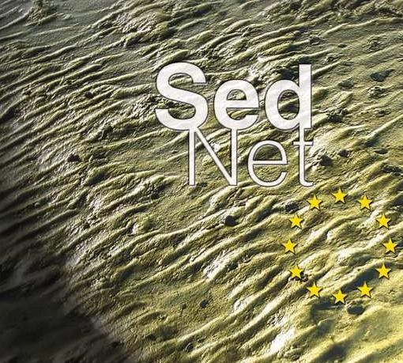
Fig. 1: Use the template Caption for labelling.
For Equations please use the equation editor and the font Times New Roman 10pt.

Results: Please save the file in the *.doc format and name it using the name of the first author according to the convention Last_First_Nr.doc.
Discussion: Please put Acknowledgements after the discussion section.

References: [1] SedNet et al. (2003) J Soils Sediments 11:111-122; [2] Dimas et al. (2004) Wasserwirtschaft 22:222-233.

Please submit your abstract before 31 October 2020 to the SedNet secretariat: marjan.euser@deltares.nl with cc to navclimate@pianc.org

